**Samsung Washing Machine (Black)**

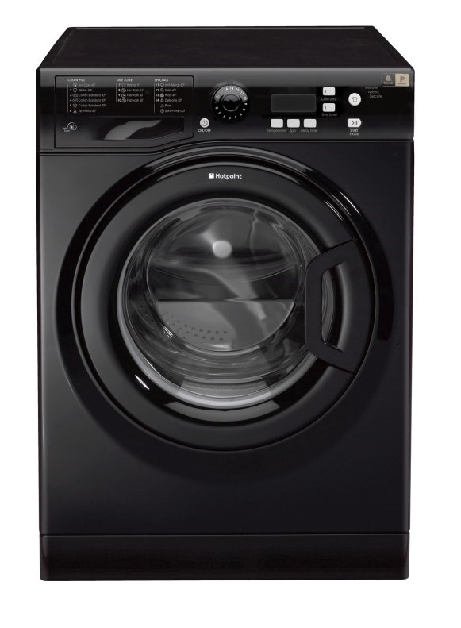

**Key Features  
  
  Front Load, Inverter Direct Drive,  
  10 Years Motor Warranty, White Color,  
  1400 RPM, 6 Motion DD,  
  Smart Diagnosis, Auto Restart,  
  Net Capacity: Washing 8 KG / Dry 5 KG  
 Price per Unit: $750/-**

**CORPORATE OFFICE**

    1300 E. Control Tower Rd.  
    Suite 216 Block L3  
    Englewood CO 80112  
 Phone: 720.974.7878  
    Toll Free: 1.877.929.7878  
    Email: [info@choicescreening.com](mailto:info@choicescreening.com)